TEMPERATURE, WEATHER & SEASONAL TIMING (APRIL IN THE UK)
April is one of the most deceptive months in beekeeping because it looks like spring, but it doesn’t behave like it consistently.
Daytime temperatures can feel warm, and you may see strong flying activity, but nights can still drop low enough to chill brood. Cold snaps, wind and rain can shut colonies down very quickly, even after a few good days.
In practical terms, this means your decisions should be based on conditions, not the calendar.
As a rough guide, inspections should only be carried out when temperatures are consistently around 13–15°C or above, with minimal wind. Below that, you risk chilling brood, particularly when the colony is still building.
What catches people out in April is the stop-start nature of the weather. A colony may be flying strongly for several days, building momentum, and then suddenly be confined for a week due to poor weather. During that time, food consumption continues, but foraging stops.
This is why April is not just “spring” — it is a transitional month between winter and full spring flow, and it needs to be treated with caution.

REALITY CHECK : Warm days don’t mean safe conditions. April can switch back to winter behaviour very quickly.
🟩 CALLOUT –
THE WORK STARTS HERE
April is where you stop “checking bees” and start managing them properly. Colonies are expanding fast, brood nests are building, and pressure inside the hive increases week by week. This is the point where your decisions begin to shape the entire season.
It’s also the point where things start to get missed. A colony can go from comfortable to congested very quickly, and small oversights now turn into swarms or losses later.

WHAT YOU SHOULD BE DOING IN APRIL
April is not just inspections. It is setup, preparation and control.
You should now be actively transitioning your apiary out of winter mode. Any remaining winter measures need to be reviewed and removed where appropriate. Roof insulation that was useful in winter can now trap moisture or heat, so it should be removed once consistent milder weather arrives. Mouse guards should also be taken off once you are confident there is no longer a risk of intrusion and colonies are flying freely.
At the same time, the apiary itself needs attention. This is the point to make sure stands are stable, hives are level, and access is clear. Water sources should be available nearby, as bees will begin using them more consistently.
This is also when you should be getting ahead with equipment. If you wait until May to order boxes, frames or foundation, you will be too late. April is when you prepare everything you might need in the coming weeks, including spare brood boxes, supers, frames, feeders and swarm control equipment.
If you are planning to use traps or bait hives for swarms, this is the time to set them up. Colonies are beginning to build towards swarming conditions, and having traps in place early increases your chances of success.
REALITY CHECK : April isn’t just about what’s in the hive. It’s about making sure everything around the hive is ready before the bees need it.

INSPECTIONS – BASED ON CONDITIONS
By April, inspections should be regular and purposeful, but never routine for the sake of it. You are no longer opening a hive just to see if bees are alive — you are checking for specific things that guide your decisions.
The first priority is always food. Colonies can still starve in April, particularly during poor weather. After that, you are confirming that the queen is laying by identifying eggs or very young larvae. Finally, you are assessing how much space the colony has and whether it is beginning to feel crowded.
Everything else you see supports those three decisions. If those three things are correct, the colony is on the right track.

Inspections should only be carried out when conditions allow. Opening a hive in temperatures below the mid-teens, particularly with wind, can chill brood and slow development. Instead of sticking rigidly to a schedule, inspections should be flexible. If conditions are not suitable, it is often better to delay a visit rather than risk damaging the colony.
When inspections do take place, they should be efficient and focused, gathering the information you need while minimising disturbance and heat loss.

PRACTICLE RULE: If you wouldn’t comfortably work without a jacket, it’s probably not ideal weather to open a hive.

FOOD – TEMPERATURE & RISK
Food risk in April is directly linked to temperature and weather patterns.
When temperatures are warm enough for flying, colonies can bring in nectar and pollen and maintain themselves well. However, when temperatures drop or conditions become wet or windy, foraging stops completely.
The key issue is that consumption does not stop when foraging does.
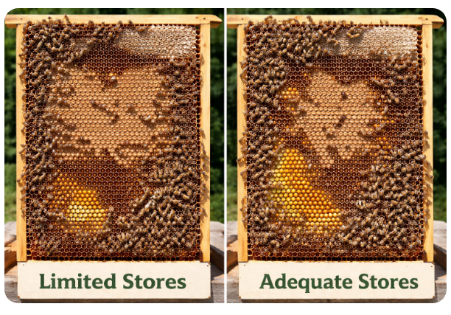
A colony with a large brood nest will continue feeding larvae regardless of weather, and this puts immediate pressure on stored food. This is why a colony can appear strong one week and be dangerously light the next.
Colder nights also increase food demand, as bees must generate heat to maintain brood temperature. Because of this, food checks should always be interpreted alongside recent and upcoming weather. A colony that looks “fine” during a warm spell may become at risk very quickly if conditions turn.
If there is any doubt, feeding should be considered. Colonies do not recover easily from starvation, and prevention is always better than trying to rescue a weakened hive.

SWARM PRESSURE – STARTING NOW
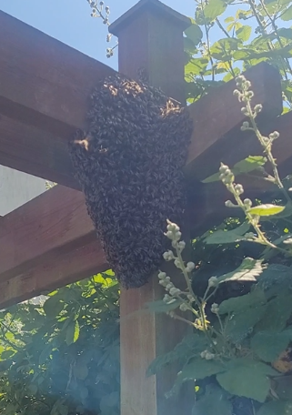
Swarm pressure begins to build in April, even if you do not yet see clear signs. The combination of increasing population, expanding brood and improving forage creates the conditions for swarming.
Strong colonies should be identified early and monitored more closely than weaker ones. These are the colonies that will cause problems if you do not stay ahead.
Swarming is driven by both colony condition and seasonal conditions. A sustained period of warm weather with good forage can accelerate development and bring swarm timing forward. Poor weather may delay it slightly, but it does not remove the pressure.
This means you should not rely on typical timing. Your focus should always be on colony behaviour rather than the calendar.
Preparation is essential. Equipment for splits or artificial swarms should already be ready. Waiting until you see queen cells to prepare is one of the most common reasons swarms are lost.
SPACE MANAGEMENT
As colonies grow, space becomes one of the most important factors to manage. If the brood box becomes congested, the colony is more likely to initiate swarm preparations.
Adding supers at the right time helps relieve pressure and allows bees to store incoming nectar efficiently. This decision should always be based on what the colony is doing, not on a fixed date.
HEALTH & OBSERVATION
April is a key observation period. You are not necessarily treating colonies at this stage, but you are identifying anything that looks unusual.
Signs such as deformed wings, crawling bees or inconsistent brood patterns should be noted and monitored. Early detection allows you to make informed decisions later in the season.

EQUIPMENT & PREPARATION
April is the point where your equipment either supports you or holds you back.
By now, you should have everything ready for the next stage of the season, not just what you need today. Spare brood boxes, supers, frames and foundation should be prepared and ready to use.
Existing equipment should also be checked. Frames that are damaged, mouldy or excessively old should be identified for replacement. Feeders should be clean and ready, and smokers should be working reliably.
If you are planning to carry out splits or swarm control, preparation for that should already be in place.
APRIL APIARY CHECKLIST
Use this at every inspection to stay consistent and avoid missing key steps.
☐ Observed entrance activity and general behaviour
☐ Checked that colonies are flying and bringing in pollen
☐ Removed mouse guards where appropriate
☐ Removed or adjusted winter insulation if no longer needed
☐ Checked hive stability, stands and apiary condition
☐ Confirmed adequate food stores in each colony
☐ Fed colonies where stores were low or uncertain
☐ Confirmed presence of eggs or young larvae
☐ Assessed brood pattern for consistency and health
☐ Checked for presence of drone brood
☐ Looked for queen cups or queen cells
☐ Assessed colony strength and population
☐ Checked for signs of congestion in brood box
☐ Added super where colony required additional space
☐ Checked for any signs of disease or abnormal behaviour
☐ Ensured water source is available nearby
☐ Prepared spare brood boxes, frames and supers
☐ Ordered any additional equipment needed for coming months
☐ Set up bait hives or swarm traps if using them
☐ Recorded inspection details and actions taken

WEEK-BY-WEEK APPROACH
At the beginning of April, the focus is on confirming winter survival and ensuring colonies have adequate stores. As the month progresses, inspections become more structured and focused on brood development and colony strength.
Towards the end of April, attention shifts more towards swarm prevention and space management, particularly in stronger colonies that are expanding quickly.
Early April often still feels like late winter, with colder nights and unpredictable weather. Mid-April usually brings more consistent flying days, while late April can feel like early summer in good years, although cold spells can still occur.
Understanding this progression helps you adjust your approach rather than treating the whole month the same.
FINAL WORD
April is where you take control of your colonies. If you stay organised, observant and prepared, the season ahead becomes manageable. If you don’t, the bees will make decisions for you.
If you only do one thing in April, make sure you stay ahead of your strongest colonies. That is where most problems start.

